Create header table:

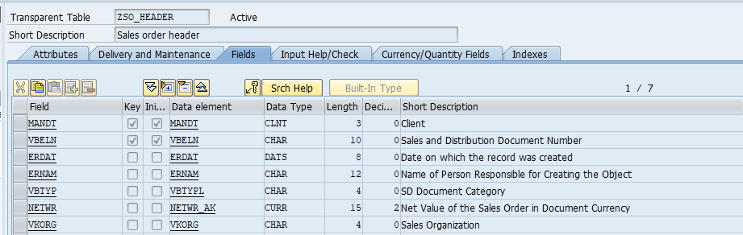

Create item table:

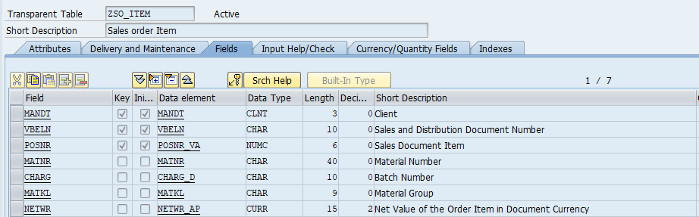

Create project in SEGW TCODE:

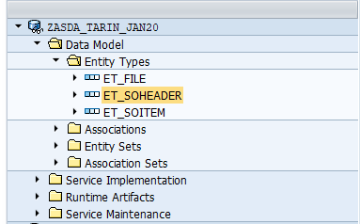

C -> ES_SO_HEADER_CREATE_ENTITY -> HTTP POST

D -> ES_SO_HEADER_DELETE_ENTITY -> HTTP DELETE

R -> ES_SO_HEADER_GET_ENTITY -> HTTP GET

Q -> ES_SO_HEADER_GET_ENTITYSET -> HTTP GET

U -> ES_SO_HEADER_UPDATE_ENTITY -> HTTP PUT

Redefine GET_ENTITY_SET and GET_ENTIY method in DPC_EXT class by double clicking on that or from SE24 TCODE:

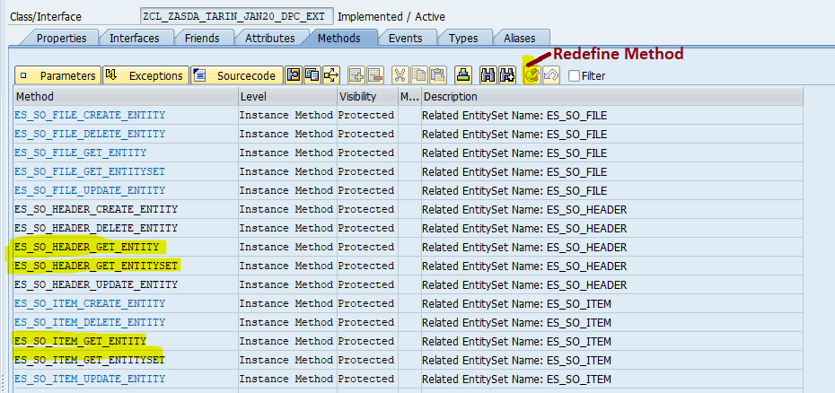

GET_ENTITY_SET for Header:

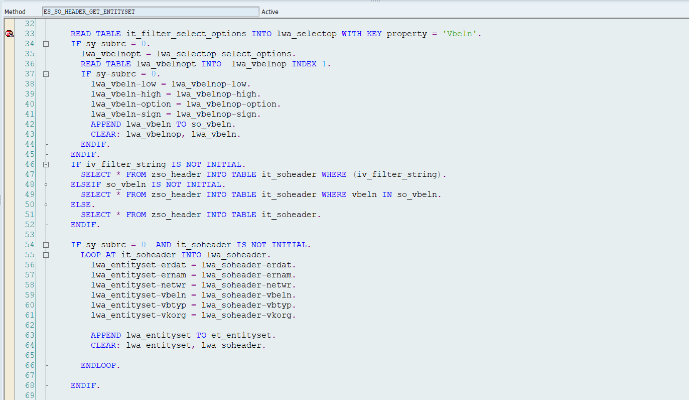

GET_ENTITY for header

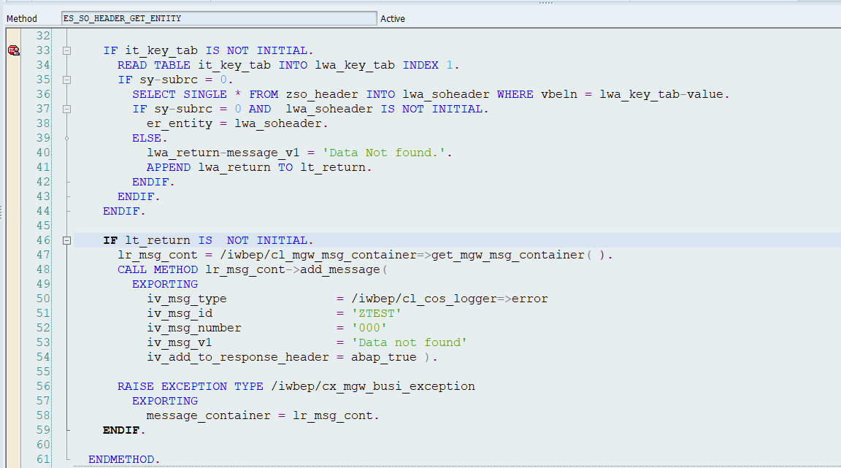

Important Points:

1. Don’t use any standard table in your ODATA...

2. Don’t change anything in MPC class or MPC_EXT

3. Don’t change anything in DPC class as well

4. Every entity type: you have 5 CRUDQ methods in the DPC_EXT class: Redefining / SE24 TCODE:

5. Always, very beginning redefine:

R -> ES_SO_HEADER_GET_ENTITY

Q -> ES_SO_HEADER_GET_ENTITYSET

6. Don’t create any data structure/variable/ type in DPC ext class.

7. At least one key field should be available in the entity type.

8. 200 – Success, 500 - internal Server Error, 400 - Bad request